- BLINKING LED’S
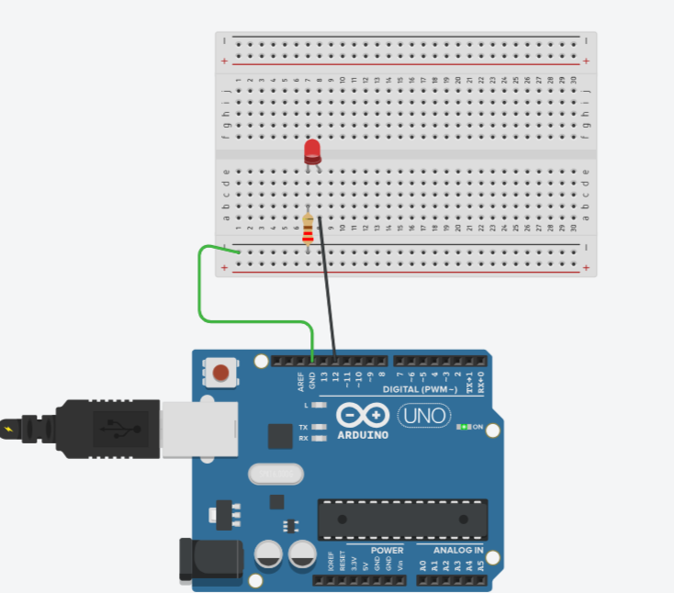

int led =12;
void setup()
{
pinMode(led, OUTPUT);
}

void loop()
{
digitalWrite(led, HIGH);
delay(1000);
digitalWrite(led, LOW);
delay(1000);
}
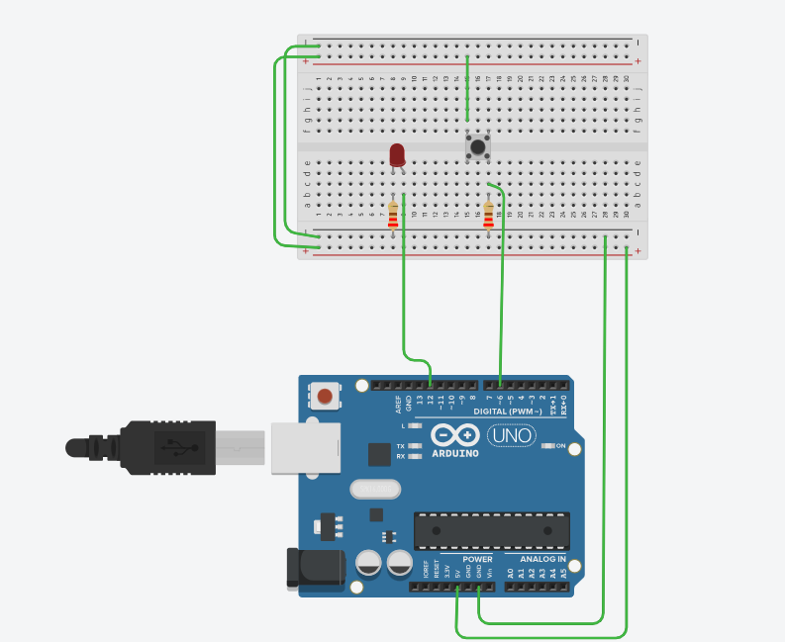
EXP-2 PUSHBUTTON LED

int buttonstate =0;
void setup()
{
pinMode(6,INPUT);
pinMode(12, OUTPUT);
}
void loop()
{
buttonstate = digitalRead(6);
if (buttonstate == HIGH){
digitalWrite(12,HIGH);
} else {
digitalWrite(12,LOW);
}
delay(10);
}

EXP-3 TRAFFIC LIGHT SIMULATION
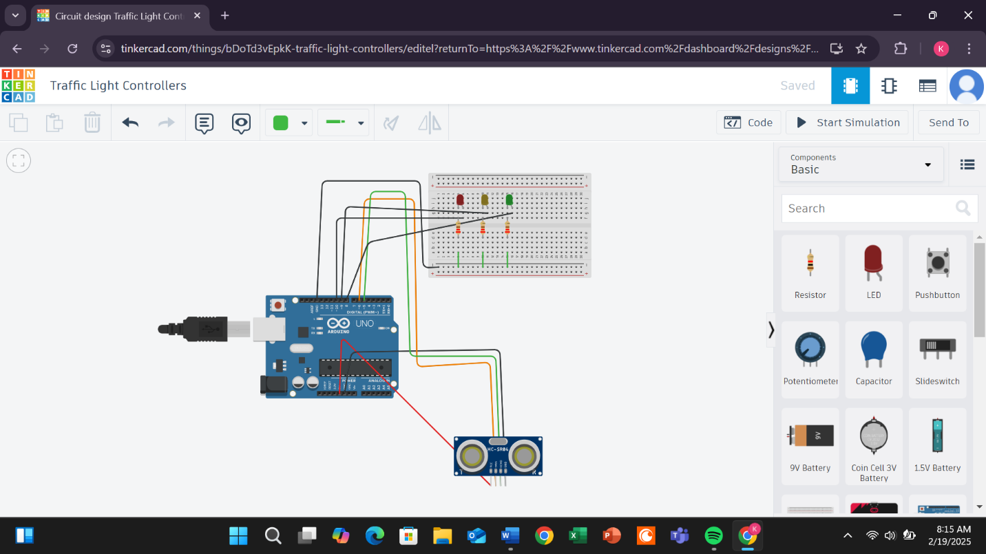

// C++ code
//
int x = 0;

long readUltrasonicDistance(int triggerPin, int echoPin)
{
pinMode(triggerPin, OUTPUT); // Clear the trigger
digitalWrite(triggerPin, LOW);
delayMicroseconds(2);
// Sets the trigger pin to HIGH state for 10 microseconds
digitalWrite(triggerPin, HIGH);
delayMicroseconds(10);
digitalWrite(triggerPin, LOW);
pinMode(echoPin, INPUT);
// Reads the echo pin, and returns the sound wave travel time in microseconds
return pulseIn(echoPin, HIGH);
}

void setup()
{
pinMode(8, OUTPUT);
Serial.begin(9600);
pinMode(9, OUTPUT);
pinMode(10, OUTPUT);
}

void loop()
{
digitalWrite(8, LOW);

x = 0.01723 * readUltrasonicDistance(6, 5);
Serial.println(x);
if (x>=0 && x<=50) {
digitalWrite(8, HIGH);
} else {
digitalWrite(8, LOW);
}
if (x>=51 && x<=75) {
digitalWrite(9, HIGH);
} else {
digitalWrite(9, LOW);
}
if (x>=76) {
digitalWrite(10, HIGH);
} else {
digitalWrite(10, LOW);
}
delay(10); // Delay a little bit to improve simulation performance
}

EXP-4 BUZZER CIRCUIT
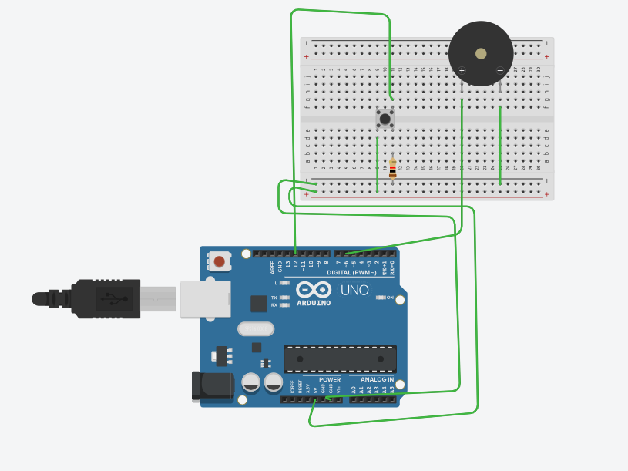
// C++ code
//
int push_button=12;
int buzzer=6;
int b=0;
void setup()
{
pinMode(push_button,INPUT);
pinMode(buzzer, OUTPUT);
}

void loop()
{
b=digitalRead(12);
if (b==HIGH){
digitalWrite(buzzer,HIGH);
} else{
digitalWrite(buzzer,LOW);
}

}

EXP-5 TEMPERATURE SENSOR AND LCD
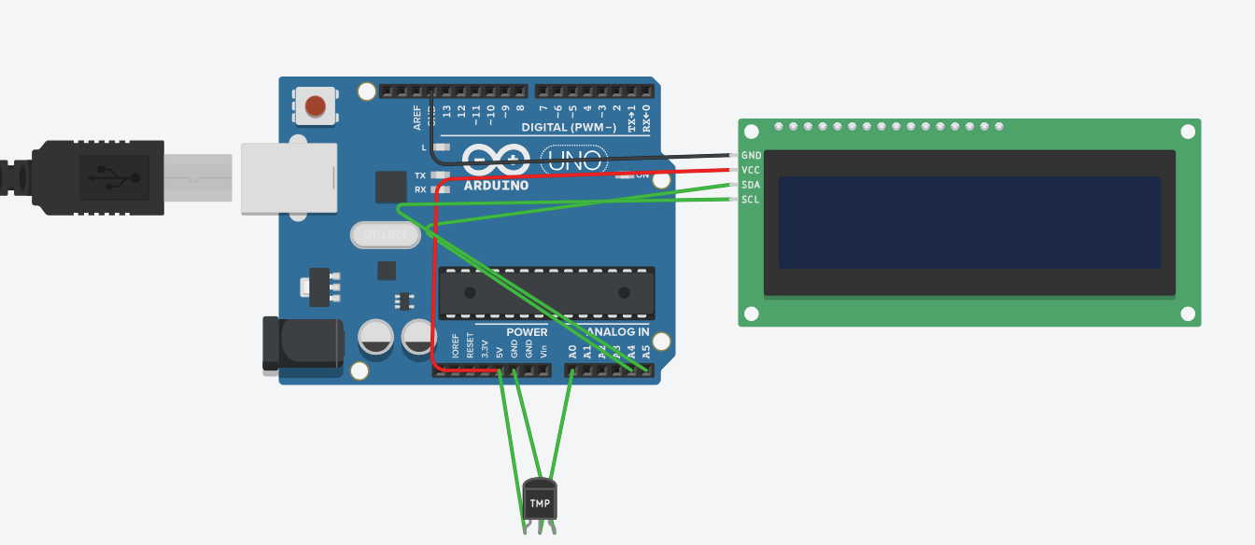
#include <Wire.h> // Library for I2C communication
#include <Adafruit_LiquidCrystal.h> // Library for the LCD

// Set the I2C address for the LCD (typically 0x27 or 0x3F)
Adafruit_LiquidCrystal lcd(0);

// TMP36 sensor is connected to analog pin A0
const int sensorPin = A0;

void setup() {
// Initialize the LCD
lcd.begin(16, 2); // 16 columns, 2 rows
lcd.setBacklight(1); // Turn on the LCD backlight

// Display welcome message
lcd.setCursor(0, 0);
lcd.print("Temp Sensor Init");
delay(2000); // Wait for 2 seconds
lcd.clear();
}

void loop() {
// Read the value from the TMP36 sensor
int sensorValue = analogRead(sensorPin);

// Convert the analog value to voltage (assuming 5V reference voltage)
float voltage = sensorValue * (5.0 / 1023.0);

// Convert the voltage to temperature in Celsius
float temperatureC = (voltage - 0.5) * 100.0;

// Convert temperature to Fahrenheit (optional)
float temperatureF = temperatureC * 9.0 / 5.0 + 32.0;

// Display temperature on the LCD
lcd.setCursor(0, 0); // Set cursor to first row
lcd.print("Temp: ");
lcd.print(temperatureC); // Display Celsius temperature
lcd.print(" C");

lcd.setCursor(0, 1); // Set cursor to second row
lcd.print("Temp: ");
lcd.print(temperatureF); // Display Fahrenheit temperature
lcd.print(" F");

delay(1000); // Update the temperature reading every second
}

#include <Wire.h>
#include <LiquidCrystal_I2C.h>
#include <DHT.h>

#define DHTPIN 2 // Pin where the DHT11 is connected
#define DHTTYPE DHT11 // Define the sensor type as DHT11

DHT dht(DHTPIN, DHTTYPE);
LiquidCrystal_I2C lcd(0x27, 16, 2); // Set the LCD I2C address

void setup() {
lcd.init(); // Initialize the LCD
lcd.backlight(); // Turn on the LCD backlight
dht.begin(); // Start the DHT sensor
}

void loop() {
float tempC = dht.readTemperature(); // Read temperature in Celsius
float tempF = (tempC * 9.0 / 5.0) + 32.0; // Convert to Fahrenheit

lcd.clear();
lcd.setCursor(0, 0);
lcd.print("Temp: ");
lcd.print(tempC);
lcd.print(" C");

lcd.setCursor(0, 1);
lcd.print("Temp: ");
lcd.print(tempF);
lcd.print(" F");

delay(2000); // Wait for 2 seconds before next update
}

